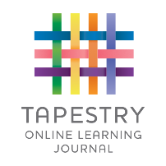
Tapestry Online Agreement Form

I give permission for Brambles Childcare Centre to create an online Tapestry Learning Journal for

…………………………………………..……………… (name of child). DOB……………………………

The people I would like to link with the account so I have access to my child’s Learning journal are

Name:………………………………………………………………………………………………

Relationship to child: ……………………………………………………………………

e-mail address:………………………………………………………………………………………………………………

Name: ………………………………………………………………………………………………

Relationship to child:……………………………………………………………………

e-Mail address……………………………………………………………………………………………………….

Agreed guidelines for accessing and using Tapestry Online Learning Journals

As a parent I will…

- Not publish any of my child’s observations, photographs or videos on any social media site
- Understand that my child’s image may be used in another child’s profile if they are engaged in the same activity. This image will not be shared by the other parent (please see above point)
- Keep the login details within my trusted family
- Speak to a member of staff if I experience any difficulties accessing my child’s learning journey

I agree to the guidelines:

Print name: _____________________________

Name of child: _____________________________

Signature: _____________________________ Date: ___________________

Please return this form to the office as soon as possible so we can set up your account and send out your login details.

